**IMPROVING DEPLOYMENT SPEED AND REDUCING PRODUCTION ISSUSES WITH DEVOPS PRACTICES**

**College Name** :City Engineering College

**Name:** Supriya S

**CAN_ID:** CAN_33870704

Modern software development demands faster and more reliable deployments. DevOps practices bridge the gap between development and operations, ensuring seamless integration, continuous delivery, and robust production stability. This project explores how implementing DevOps principles enhances deployment speed while minimizing production issues.

**Docker** is a containerization platform that enables developers to package applications into **containers** that include everything needed to run the application—code, runtime, libraries, and dependencies.

**Key Benefits of Containerization:**

* **Portability**: Containers can run on any system that supports Docker, eliminating the "works on my machine" problem.
* **Scalability**: Containers can be easily replicated and deployed to handle increased workloads.
* **Consistency**: The same containerized application can run in development, testing, and production environments without changes.
* **Efficiency**: Containers are lightweight and use system resources more efficiently than virtual machines.

**Orchestration with Kubernetes (K8s)**

**Kubernetes** is an open-source orchestration tool that manages containerized applications at scale. It automates deployment, scaling, and operations of application containers across clusters of machines.

**Key Kubernetes Components:**

* **Pods**: The smallest deployable unit in Kubernetes, consisting of one or more containers.
* **Deployments**: Define how containers should be created and managed.
* **Services**: Expose application components to other services or users.
* **Ingress**: Manages external access to services inside the cluster.
* **ConfigMaps & Secrets**: Manage configuration and sensitive data separately from application code.

**Implementing Containerization and Pushing to Docker Hub Container Registry**

**Setting Up a CI/CD Pipeline**

1. **Code Repository: Store source code in GitHub/GitLab.**
2. **Automated Testing: Run tests using Jenkins/GitHub Actions.**
3. **Build and Containerization: Use Docker to package applications.**
4. **Deployment Automation: Deploy using Kubernetes.**
5. **Monitoring and Feedback: Use Prometheus, Grafana for real-time monitoring.**

**6.Building Images:**

docker build -t $DOCKER_HUB_USERNAME/frontend:latest docker build -t $DOCKER_HUB_USERNAME/backend:latest .

**7.Push Images to Docker Hub:**

docker push $DOCKER_HUB_USERNAME/frontend:latest docker push $DOCKER_HUB_USERNAME/backend:latest  **8.Create Kubernetes Deployment and Service YAML Files**  Create a file named frontend-deployment.yaml:

apiVersion: apps/v1 kind:

Deployment metadata: name: frontend spec: replicas: 1 selector: matchLabels: app: frontend template: metadata: labels:

app: frontend spec: containers: - name: frontend image: dockerhub-username/frontend:latest

ports:

- containerPort: 80 **Frontend-service.yaml** apiVersion: v1 kind:

Service metadata: name: frontend spec: type: NodePort ports: - port: 80

nodePort: 30001 selector: app: frontend

**Kubernetes Deployment YAML:**

apiVersion: apps/v1

kind: Deployment metadata: name: app spec: replicas: 2 selector: matchLabels: app: app template: metadata: labels:

app: app spec: containers:

* name: app image:

dockerhub-

username/app:latest

ports:

* containerPort:

3000**ServiceConfigur ation**

apiVersion: v1 kind: Service metadata: name: app-service spec: type: LoadBalancer ports: - port: 80 targetPort: 3000 selector: app: app

**Overview of Containerized Application Deployment**

|  |  |
| --- | --- |
| **Aspect** | **Description** |
| **Features** | **Portability** – Containers run consistently across different environments (local, cloud,hybrid).  **Isolation** – Each container operates independently, preventing dependency conflicts.  **Lightweight** – Shares host OS kernel, making it more efficient than VMs.  **Scalability**–Easily scale up/down based on demand.  **Automation** – Kubernetes automates deployment, scaling, and management.  **Security**–Controlled access through security policies.  **Fast Deployment** – Containers start quickly, reducing downtime. |
| **Aspect** | **Description** |
| **Benefits** | **Consistency** – Ensures uniform behavior across environments.  **Efficient Resource Utilization** – Uses fewer system resources than VMs. **Microservices Compatibility** – Enables modular application design and independent scaling.  **Rapid Scaling** – Adapts quickly to workload changes. |
| **Best**  **Practices** | **Use Small, Efficient Containers** – Avoid bloated images.  **Minimize Privileges** – Run containers with the least privileges.  **Optimize Docker Images** – Use multi-stage builds to reduce image size. **Monitor & Log Containers** – Implement **Prometheus, Grafana, or ELK Stack** for monitoring.  **Use Kubernetes for Orchestration** – Automate deployment, scaling, and networking.  **Secure Container Images** – Scan for vulnerabilities before deployment. |

**Manage Storage & Networking** – Use **persistent storage** and secure **network policies**.

**Conclusion:**

By integrating DevOps practices, software teams can significantly improve deployment speed while minimizing production issues. The implementation of CI/CD pipelines, containerization, and automated testing ensures reliable and scalable deployments. Organizations adopting DevOps benefit from faster releases, increased efficiency, and robust system performance.

**Future Enhancements**

1. Advanced Security Measures – Implement DevSecOps for enhanced security.
2. Multi-Cloud Deployments – Extend applications across AWS, Azure, and GCP.
3. AI-Driven Monitoring – Use AI for predictive analysis and anomaly detection.
4. Serverless Architectures – Reduce infrastructure management with FaaS platforms like AWS Lambda.

**SCREENSHOTS**

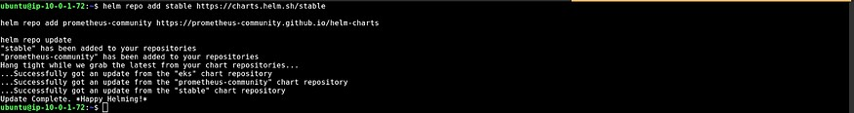

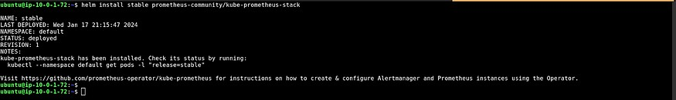

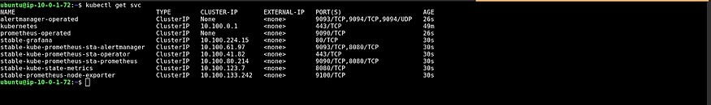

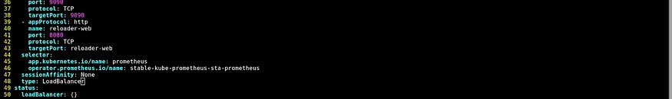

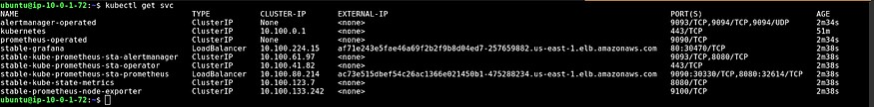







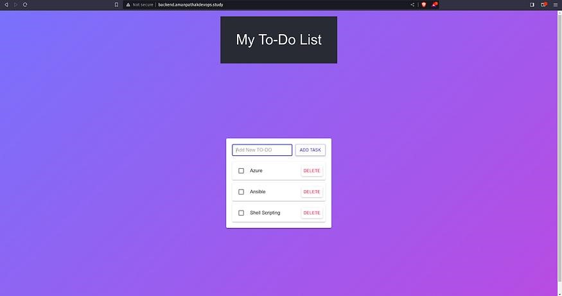

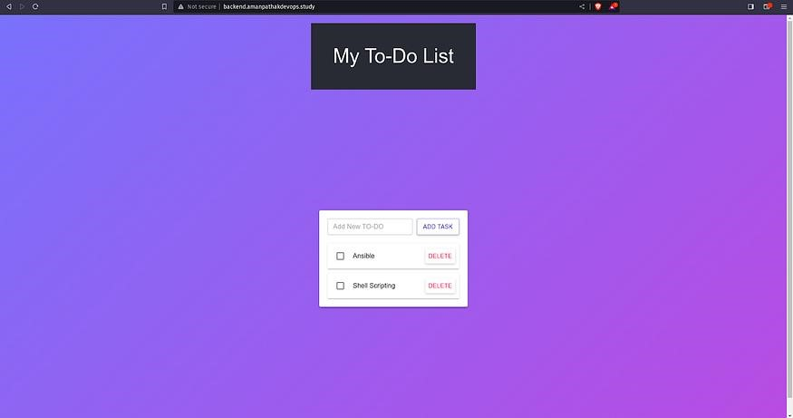

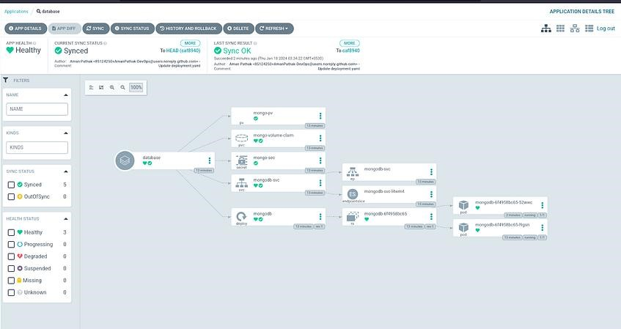

Github Link:

[https://github.com/keerthanaaa24/IMPROVING-DEPLOYMENT-SPEED-AND-REDUCINGPRODUCTION-ISSUSES-WITH-DEVOPS-PRACTICES-.git](https://github.com/keerthanaaa24/IMPROVING-DEPLOYMENT-SPEED-AND-REDUCING-PRODUCTION-ISSUSES-WITH-DEVOPS-PRACTICES-.git)